Content Strategy Memo: Netflix Catalog Trends
Prepared by: Sneha Dubey | Data: Netflix (8,807 titles) and Amazon Prime (9,668 titles) from Kaggle, till 2021
Maine catalog ko genre, country, release year aur movie length ke hisaab se dekha. Neeche 3 baatein hain jo content team ke kaam aa sakti hain.

Insight 1: TV Shows tezi se badh rahe hain
Evidence: Catalog mein 70% movies (6,131) hain aur 30% TV Shows (2,676). Par 2015 mein naye releases ka sirf 29% hissa TV Shows tha, 2020 tak ye 46% ho gaya.
Recommendation: Limited series aur short-season shows ko priority do, kyunki ye share already badh raha hai.
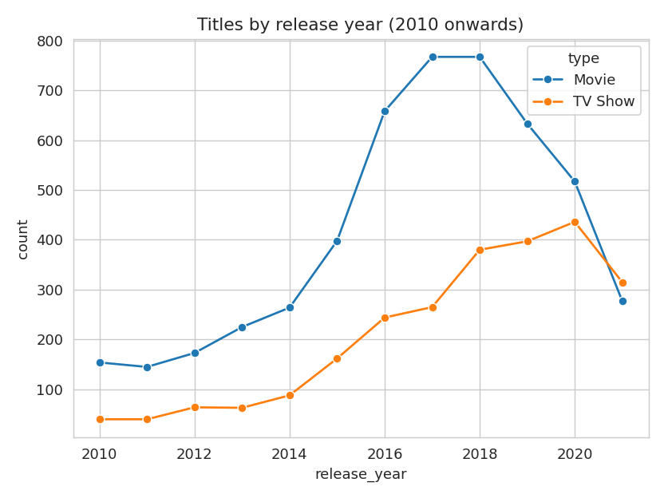

Insight 2: India dusra sabse bada market hai
Evidence: US ke 3,211 titles ke baad India ke 1,008 titles hain, UK ke 628 se kaafi aage. Genre mein Dramas (1,600) aur Comedies (1,210) sabse upar hain.
Recommendation: Indian drama aur comedy mein local originals par invest karo. Catalog mein India ki maujoodgi pehle se hai, par US se abhi bhi teen guna kam hai.
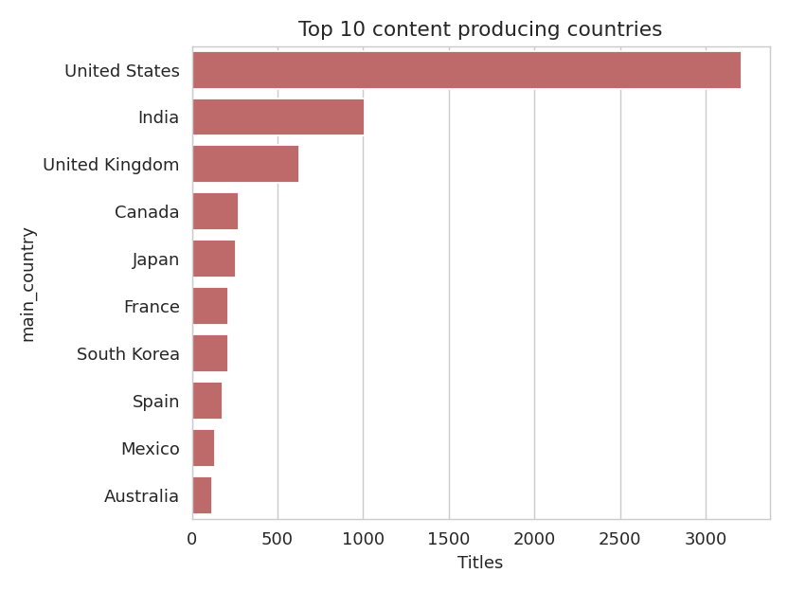

Insight 3: Movies chhoti ho rahi hain
Evidence: 2000-02 mein average movie lagbhag 115-119 min ki thi. 2020 tak ye ghatke 92 min reh gayi.
Recommendation: 90 min ke aas-paas ki movies banao ya acquire karo, ye log aasani se ek baar mein dekh lete hain.
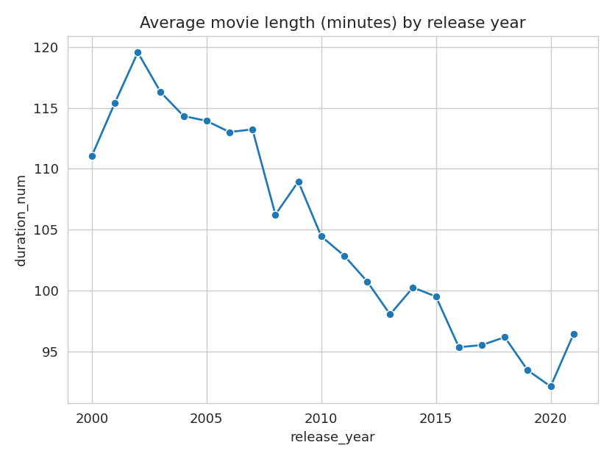

Bonus: how Prime is different
Evidence: Prime is more movie-heavy (81% movies vs 70% on Netflix), has a bigger older catalog (17.5% titles from before 2000 vs 6%), more Action and Horror, and shorter movies (91 min vs 100 min). Netflix has more Comedy, Documentaries and adult-rated titles (46% vs 24%).
Recommendation: To stand apart from Prime, Netflix should keep investing in recent comedy and documentary content, and leave the old library and action/horror volume to Prime.
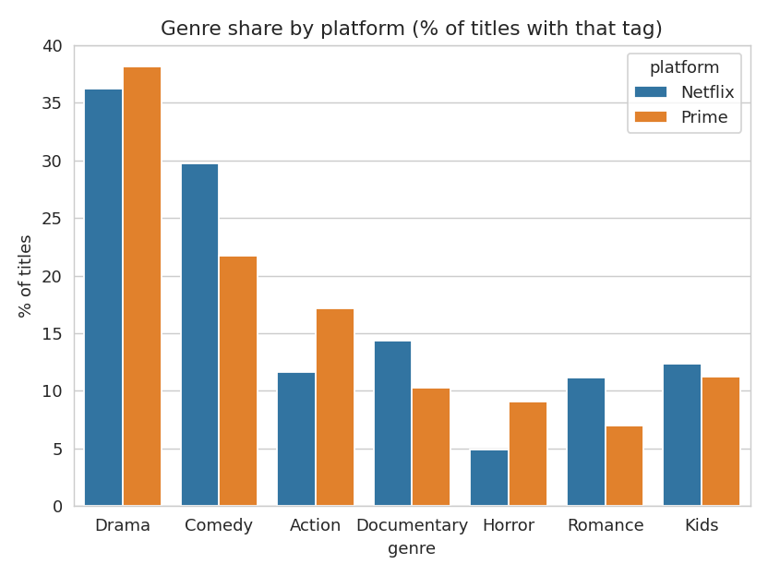

Conclusion
Catalog abhi bhi movie-heavy hai, par naya content shows aur regional kahaniyon ki taraf ja raha hai. Limitation: har title ka sirf pehla country aur genre liya gaya hai, aur 2021 ka data adhura hai. Prime ka data sirf type, genre, length aur rating ke comparison ke liye use hua, kyunki usme country aur date bahut kam bhari hain.

